**Rag Week Website**

**Cecelia Mcconell**

**Darien Cortez**

**Darragh Wilkes**

**Fenella Morin**

**Gurveer Ayala**

**Khadeekah Kemp**

**Maksim Mcmanus**

**Marcos Ali**

**Nikodem Cortes**

**Project Goal**

To develop a PHP web application that will allow administrators to add event information about rag week at LIT. The events and related charities will be readily available to students at LIT. A memorable domain name will be permanently registered and hosted to provide easy access to the website. The website will be updated every year to reflect new information every year.

**Work Breakdown Structure**

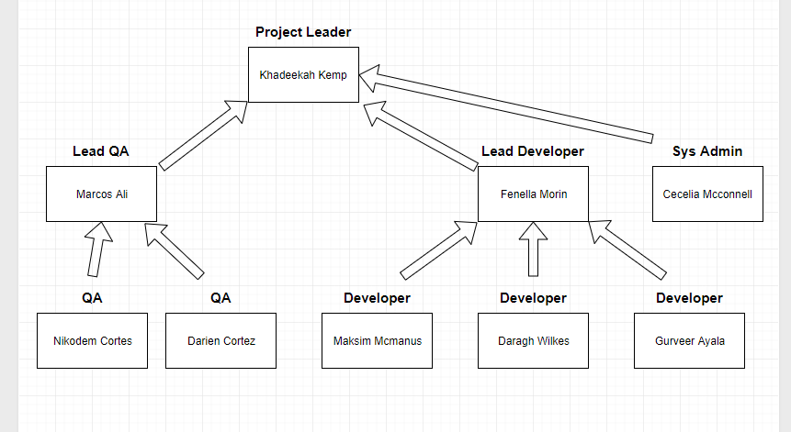

**List of Jobs**

|  |  |
| --- | --- |
| **Job Nr** | **Description** |
| 1 | Register domain name |
| 2 | Set up web hosting |
| 3 | Compile event and charity event information |
| 4 | Decide on a design of the website |
| 5 | Develop wireframes for the layout of the site |
| 6 | Implement design in html and CSS |
| 7 | Implement a PHP Framework ie. CodeIgniter |
| 8 | Design and implement database to support the application |
| 9 | Implement user authentication for admins |
| 10 | Implement event management |
| 11 | Test user authentication |
| 12 | Test event management |

**Khadeekah Kemp – Project Leader**

**Marcos Ali – Lead QA**

**Fenella Morin – Lead Developer**

**Cecelia Mcconell – Sys Admin**

**Maksim Mcmanus - Developer**

**Darragh Wilkes - Developer**

**Gurveer Ayala - Developer**

**Nikodem Cortes - QA**

**Darien Cortez - QA**